Pre-Reading

Dad likes Fruit
The first new character introduced is 可 (ke3), which means can or able, and used with the character 能 refers to the possibility of something. For example, you can say 我可能去 or as negated in the story 我不可能去. 不可能 is commonly used in Chinese to mean that something is impossible. For example, you can say, 我的作业很多，今天不可能做完 (I have a lot of homework, it is impossible to finish). In the second sentence, when the speaker's father explains why it was impossible for him to steal the school supplies, he reveals that he 不喜欢 (bu4xi3huan1) those things. 喜 is always used with the second character 欢 to form the verb to like. 欢, which means pleased or happy, commonly precedes the character 迎 ying2, and when it does, the word 欢迎 means to welcome. For example, you can say, 欢迎你来我家 which would mean welcome to my home. The second sentence begins with 如果 (ru2guo3). Although 如 by itself has the meaning of if or as if, it typically precedes 果, which means fruit or result. Thus 如果means “as if the result”, or “if”. However, be careful when using this structure because unlike in English, where “if” can be placed in the middle of a sentence, in Chinese it can only be placed in front of the first clause. In English for example, you may either say, “If you don't go, I won't go” or you can say “I won't go if you don't go.” In Chinese, you may say 如果你不去，我也不去 but you can't say 我不去如果你不去. The “if” structure is followed by 肯定 (ken3ding4), which means “certain or definite.” For example, you may say 我肯定要去 (wo3ken3ding4 yao4 qu4) “I will go for sure.” Next in the sentence is 水果 (shui3guo3) 水 here meaning water and 果 meaning melon, so fruit are eatable things that contain water. You've already encountered 果, and although it means fruit in the general sense, when referring to fruit in the food sense, it is usually preceded by 水. Thus there are many types of 水果, such as 苹果 (ping2guo3) which is apple and 芒果 (mang2guo3) which sounds very similar to Mango. However, most individual 水果 do not have 果 in the word, such as 草莓 (cao3mei2), 香蕉 (xiang1jiao1) banana, and 西瓜 (xi1gua1) watermelon.
The character 也 (ye3) which means “also”, as you may have already noticed, is the right side of 他 and 她. It is always placed in front of the verb. Examples 我也不喜欢他 and 我也不想做作业. Here you find 别 used in a different way. 别 preceded by 特, or 特别 means “especially or extremely.” For example you may say, 我特别要去 “I really want to go” or 我特别喜欢学汉语 “I really like studying Chinese.” Mentioned above in the fruit examples, you may have noticed 草莓. The second character 莓 is used to refer to berries. According to the Chinese, strawberries are a berry of 草, which is grass. In fact, many organic things will include the character 草, especially Chinese herbs and medicine. Be sure to take note of the top part of 草, the diagonal line with two horizontal lines going through. This is called the grass component 草字头and is found in almost all characters used to refer to plants.
Story Character Count = 73

Vocabulary/Writing

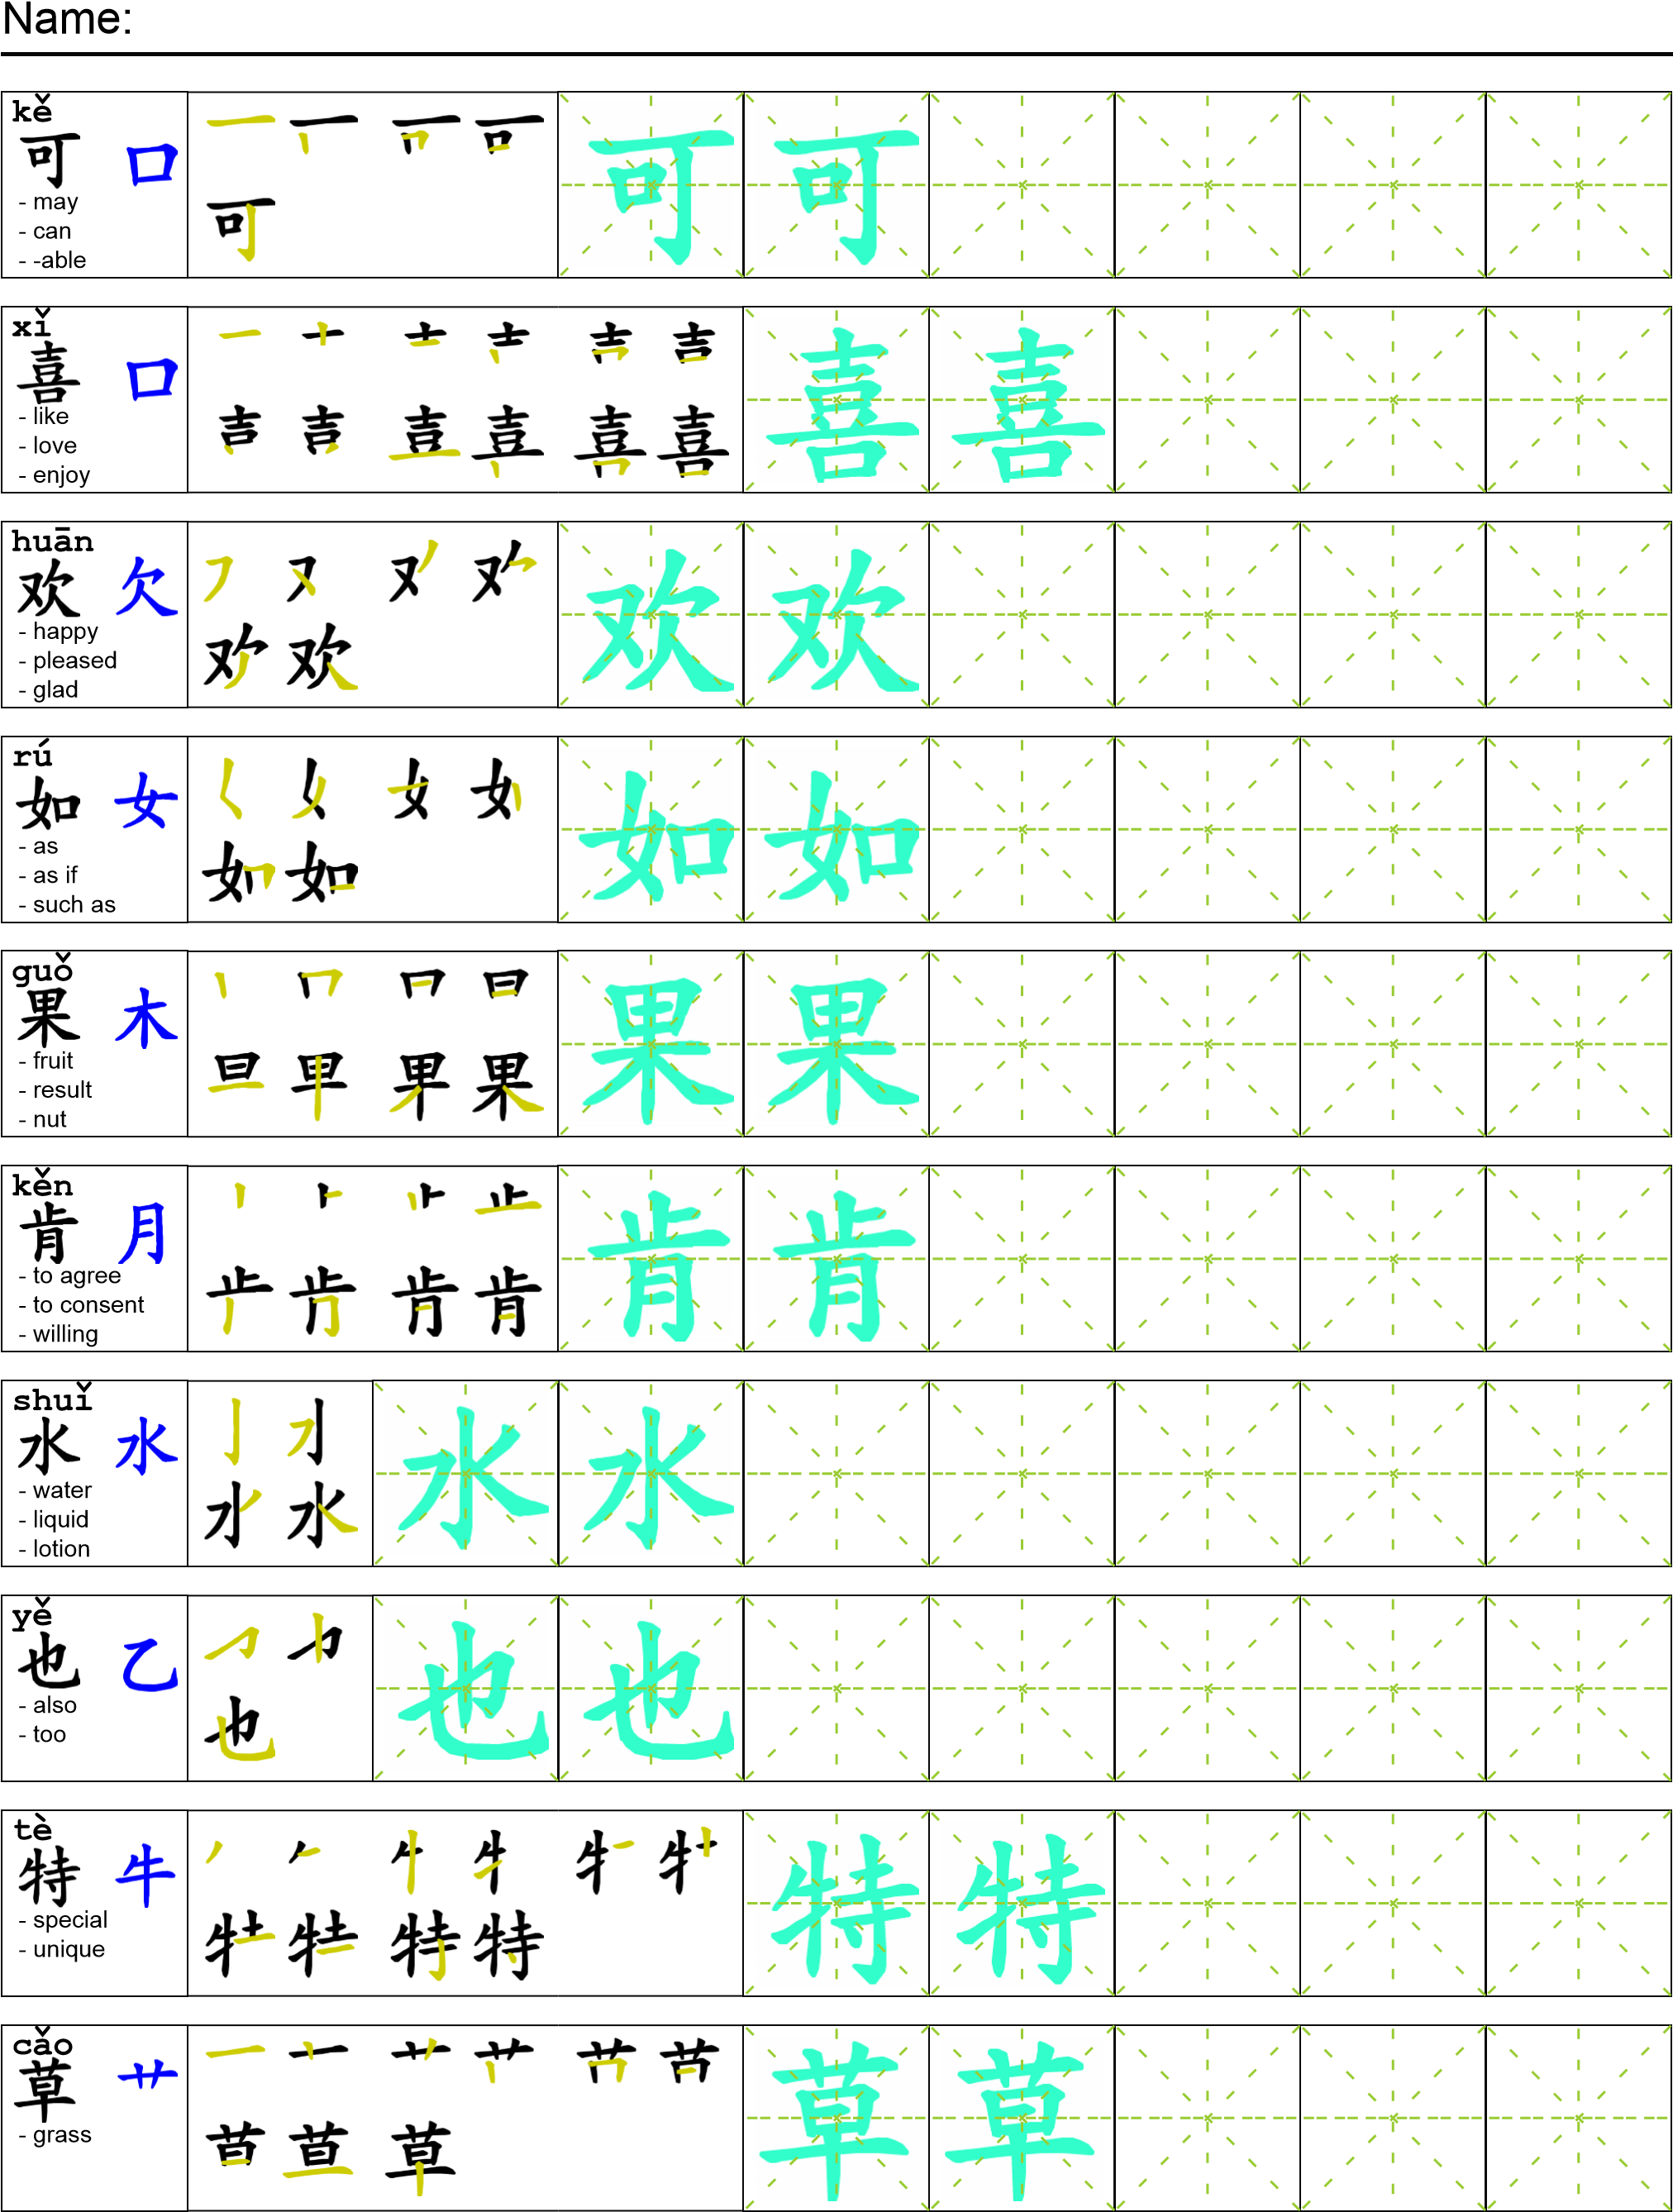
Reading

我爸爸说“我不可能偷学校用品。我不喜欢那些东西。如果我是小偷我肯定要偷水果。我最喜欢苹果和草莓。我也特别喜欢香蕉和葡萄。”我跟我妹妹说“那如果爸爸不是小偷那谁是小偷?”
Task Completion

Once all tasks are complete turn the assignment in to collect the points for the project.
Task 1: Trace the vocabulary and copy the text into your notebook.

Task 2: Answer Comprehension Questions.

Task 3: Write the Pinyin for the Reading.

Task 4: Translate the Reading into English.

Task 5: Record yourself reading the passage.

Comprehension Questions
- 你喜欢什么水果？ （写三个）_______________________________________________?
- 你不喜欢什么水果 (写三个) __________________________________________________?
- How do you express that something is not possible in Chinese? ______________________?
- Which character means berry? Fruit? ___________________________________________

